Name: Mukesh Prajapati
Date: FEB/15/2018, Created
Brief: Valgrind documentation
Valgrind

What is valgrind?

Valgrind is a memory mismanagement detector. It shows you memory leaks, deallocation errors, etc. Actually, Valgrind is a wrapper around a collection of tools that do many other things (e.g., cache profiling); however, here we focus on the default tool, memcheck. Memcheck can detect:

Use of uninitialised memory
- Reading/writing memory after it has been free'd
- Reading/writing off the end of malloc'd blocks
- Reading/writing inappropriate areas on the stack
- Memory leaks -- where pointers to malloc'd blocks are lost forever
- Mismatched use of malloc/new/new [] vs free/delete/delete []
- Overlapping src and dst pointers in memcpy() and related functions
- Some misuses of the POSIX pthreads API
How to install?

Run the following command in terminal,
$sudo apt-get install valgrind

What is memcheck?
Memcheck is a memory error detector. It helps you make your programs, particularly those written in C and C++, more correct.

How to check the memory leakage?

Pre-Condition: You should have any C program executable.
Syntax: valgrind –leak-check=yes <executable file_name> <arguments If any>

Example:
Prorgam file name: 2_StructureProgram.c
Executable file name : DataStructure
Check : $valrgind –leak-check=yes ./DataStructure

It will display like following

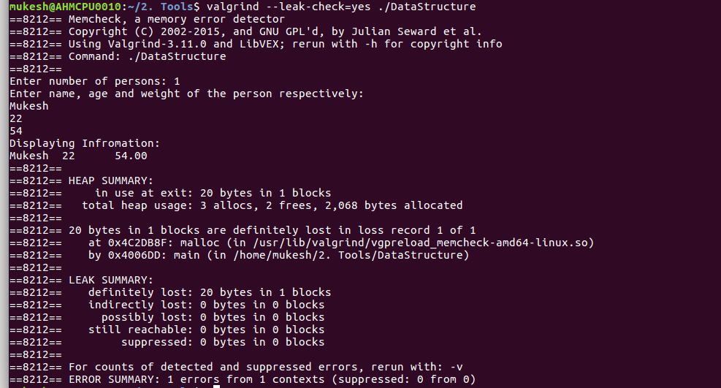
Check the LEAK SUMMARY details.

There is 20 bytes lost in 1 block.
But we don’t know actual line is where we need to free up things.
So, to know line number compile program through following command,

$gcc -g -o <executable filename> <your program filename>

Let’s see,
$gcc -g -o DataStructure 2_StructureProgram.c

Now it will display line number as well,
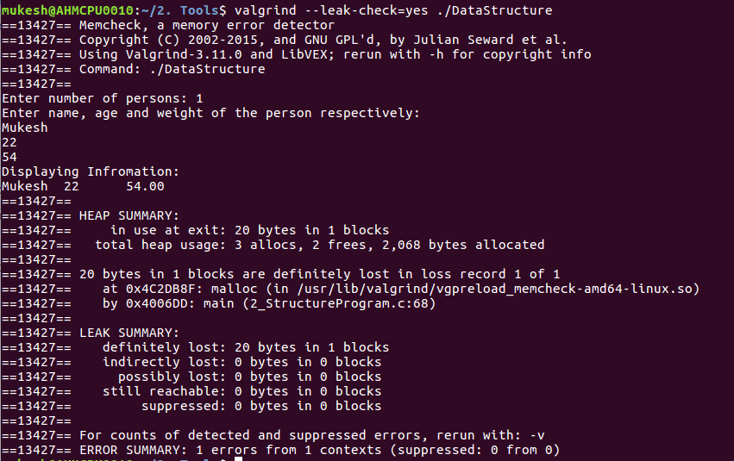

It is showing in ==13427== by 0x4006DD: main (2_StructureProgram.c:68)
Means memory is leaking at the line number 68.

This is how we can change memory leakage through valgrind.

